

701 E. WHITESTONE BLVD.
SUITE 200
CEDAR PARK, TX 78613
www.workforcesolutionsrca.com

Vendor Registration Notice
March 23, 2026
Workforce Solutions Rural Capital Area (WSRCA) wishes to inform you, effective immediately, all formal bidding solicitations, subsequent addendums, and awards will be published and managed on the Euna Procurement/Bonfire (Bonfire) platform. WSRCA has also updated our procurement information on the website, please see https://workforcesolutionsrca.com/procurement.
Vendors will need to register in Euna Procurement/Bonfire to access WSRCA solicitation documents and submit proposals and/or quotes to open solicitations through the Euna Procurement/Bonfire portal. WSRCA will notify registered vendors via Bonfire of open solicitations that match our requirements.
The current vendors list will remain open through April 30, 2026, after which time WSRCA will use only vendors registered in Bonfire.
Interested Vendors please register for free with the Workforce Solutions Rural Capital Area Bonfire Portal at https://workforcesolutionsrca.bonfirehub.com/.
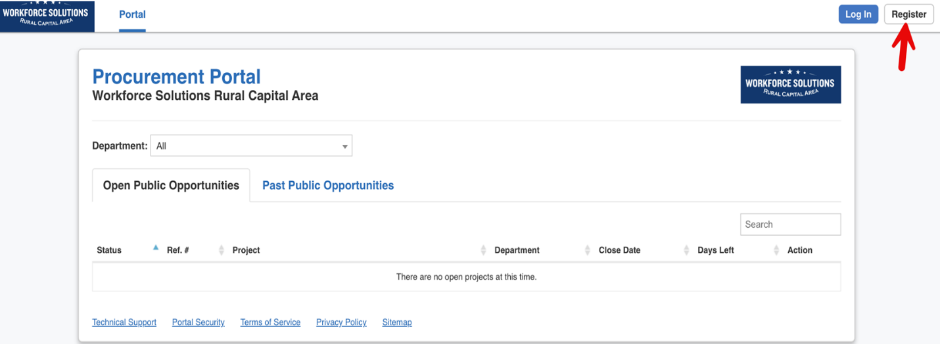
For Euna Procurement/Bonfire registration questions, you can reach out to Euna Procurement Support at address, support.bonfire@eunasolutions.com.

Advertisement
In addition to posting solicitations on Euna Procurement/Bonfire, WSRCA advertises open solicitations on the WSRCA website, https://workforcesolutionsrca.com/procurement and on the Texas State Comptroller of Public Accounts Electronic State Business Daily (ESBD) website, https://www.txsmartbuy.gov/esbd to notify the public of open solicitations.
Vendor registration in Euna Procurement/Bonfire is still required to submit proposals. It is the responsibility of Vendors to check any of the mentioned sites for open solicitations.

