
701 E Whitestone Blvd, Suite 200
Cedar Park, Texas 78613
Phone: 512.244.7966
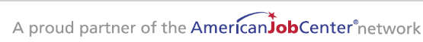
Fax: 855.326.3055
www.workforcesolutionsrca.com

workforce solutions rural capital area
business education committee agenda

April 6th 2026, 12:00PM

agenda

- Call the meeting to order/roll call- Nikki Stallings at 12:03 pm
Attendees:
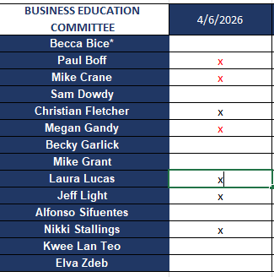
- Vote on meeting minutes from January meeting- postponed – Kelly will send out email vote for January and April meetings
- Icebreaker Question- Any exciting summer plans being made? What updates do you have about the work of your organizations or things happening in your community that WSRCA can support or benefit from? None
- Business Services Workshop Working Group will review at July 20th meeting. Kelly will forward invite to the next meeting.
- Kelly showed the Career Connect website, Beta testing should start at the end of April, we will need your help in testing it/
- Kelly shared information on the industry booklets the K12 team created and will be shared with the ISDs. Laura Rosen shared information about the Regional Healthcare Workforce Strategy Session scheduled on 4/23/2 at 5:30 pm in Smithville - https://www.ruralwholehealthcoalition.org/event-details/regional-healthcare-workforce-strategy-session

- Next Board of Directors Meeting – 4/15/26 -12:30 pm at the Round Rock Office
- Adjourned at 12:31 pm

Please use this link to for minutes approval - https://forms.office.com/g/GpPr4MAsdX

Committee Goals:

Technical items:
- Determine the Self-Sufficiency/Living Wage for the service area; Identify Target Industries driving the local economies; Identify demand occupations within those target industries; Target Occupations within the demand occupations; establish performance standards for eligible training providers to continue providing training.- Completed in Feb 2025. Will do again in Feb 2026.

Training/Education for Board Members:
  - Inform the committee and business community on labor market trends, etc.
  - Identify and invite industry, city/county experts and elected leaders to board meetings or immersion days to gain an understanding of the Board’s role in economic development.

Advancing WSRCA’s Business Services Objectives:
  - Provide direction to Board and staff on outreach and activities to increase the number of businesses accessing business services.
  - Identify and promote the Board’s value adds to business—center services, training grants.
  - Explore charging business for identified services (i.e., assessments, screening) and diversifying funding.

Advancing WSRCA’s Impact on Education (K-12 to Higher Ed):
  - Assist in planning structured education and business conversations to match business skills needs with education curriculum, and review information obtained during these meetings.
  - Develop and promote (specifically to students) career pathway information that leads to higher wage jobs in each county.
  - Provide recommendations and review data on how soft skills are provided in all High Schools and Colleges in the region.

