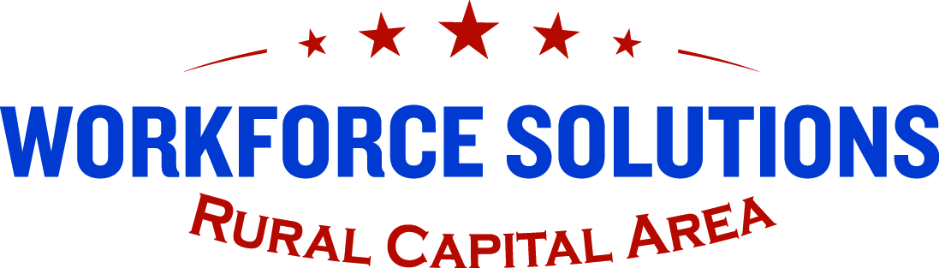

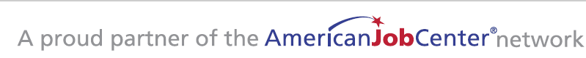

Meeting held oN FEBRUARY 25, 2026
Workforce Solutions of Hays County | San Marcos, TX
Board Meeting Minutes

Agenda Item #1

Call to Order/Roll Call – Frank Leonardis

Abbott | P | Grant | P | Riggs | Pv
Boff, Paul | P | Johnson | Pv | Sifuentes | P
Brockman-Weber | Pv | Kimball | A | Stallings | Pv
Crane | A | Leonardis | P | Stewart | P
Cruz | A | Light | A | Swartz | Pv
Dowdy | Pv | Lindsey – Non-Vote | P | Teo | A
Engebretson | Pv | Lucas | Pv | Wagner | A
Estelle | P | Miller | A | Zdeb | P
Fletcher | P | Mudd | P
Flores | Pv | Ols | Pv
Gandy | P | Paselk | P
Garlick | A | Payne, Amy | Pv
*v- Present/attended virtually

_23 of 31__ members present at roll call. Alfonso Sifuentes joined during policy discussion and began his voting rights on that line item. He was excluded from quorum counts on the budget and consent agenda!
Quorum established ☒ YES
Roll call sheet in meeting binder/check off

Agenda Item #2

Public Comment Period

No Public Comment

Agenda Item #3
Information Sharing –
- Welcome to visiting guests
  - Grace Chirico presented Child Care Customer Service Award

Agenda Item #4
Audit Overview (Year ending: September 30, 2025)
- Summary Presented by Martinez, Rosario & Company, LLC. To WSRCA Board of Directors
  - Overall a successful audit with complete executive summary presented to WSRCA Executive Committee and included in WSRCA Board Packet.

Agenda Item #5
Workforce Program Updates

- Targeted Occupations
  - Discussion and Recommendations (complete summary included in packet)
- Self Sufficiency Wage
  - Discussion and Recommendations (complete summary included in packet)
- UI Work Search
  - Discussion and Recommendations (complete summary included in packet)

Agenda Item #6
Consent Agenda*

- Adopt meeting minutes from previous Board Meeting- December 10, 2025
- November and December 2025 Financial Reports

*All consent agenda items approved.

Agenda Item #7
Chairman’s Report – Frank Leonardis

- Executive Committee Meeting February 18, 2026
  - Updated minutes/summary in next Board Meeting packet
  - Auditor’s Report (Presented by Milo Martinez, CPA)
    - Clean Audit, No Current Findings
  - Nov and Dec 2025 Financial Reviews (Presented by Gavin Wilson, YPTC)
  - Cybersecurity Report (Presented by Eric Stanfield, WSRCA CIO)

+ Complete summary in Board Meeting Packet
Next Meeting: April 8, 2026, 2:00pm

Agenda Item #8
Business Education Services Committee Report- January 21, 2026

- complete summary report in packet
- Krissy Wells, Deputy Director Business Solutions w/C2 introduction
- Review Target Occupation List
- Design Business Engagement Training for BOD

Next Meeting: April 6, 2026

Agenda Item #9
Community Awareness Committee Report – February 11, 2026

- Committee project suggested by K. Schwartz; Regional Signing Day
- Outreach Updates

Next Meeting: TBD

Agenda Item #10
Untapped Populations Committee Report

- Committee under reconfiguration- will re-introduce in January 2026
- Did not meet/No report for this month

Next Meeting: TBD

Agenda Item #11
Early Care & Education Committee Report- February 5, 2026

- Review of ECE Board Committee mission and purpose
- Overview of Early Learning and Child Care Strategic Plan

Next Meeting: TBD

Agenda Item #12
Chief Executive Officer Report- Paul Fletcher

- Meeting in Fort Worth w/C2 Global Partners and C2 Contracted Boards
- Noted new TWC Executive Director- Stephen Pier
- NAWB upcoming in Las Vegas, Nevada- WSRCA presenting at conference
- Workforce Innovation Grant Awardee
- Military to Civilian Grant Awardee

Agenda Item #13
Performance Reports- Diane Cook

- Overall FY 24-25 completion on target per expectations
- RHI Grant- surpassing 100% of expectations
  - Will close out in ‘26
- Good Jobs Challenge Grant- surpassing 100% of expectations
  - Will continue thru Aug ‘27
- Continued apprenticeship expansion
  - Grant 2- 101% enrollment
- Child Care Contract- continued increase for FY ’26 (increase of 500 enrollees anticipated)

Agenda Item #14
WSRCA board Announcements

- Onboard was introduced and utilized at Board Meeting
- Final Thank You to all members/staff/partners

Agenda Item #15
Next Meeting:

- April 15, 2026 @12:30pm- WSRCA Round Rock, TX

- Final Thank You to all members/staff/partners

Agenda Item #16
Adjourn

